**Mid Exam Simulation #2**

1. A sample of the data of the amount of water in liter used by some washing machines are of the following.

|  |  |  |  |  |
| --- | --- | --- | --- | --- |
| 5.5 | 1.1 | 6.5 | 4.9 | 6.4 |
| 7.0 | 1.5 | 5.7 | 5.9 | 5.4 |
| 6.1 | 1.2 | 7.3 | 6.1 | 4.4 |

Write a python program to compute the statistic descriptive of the sample data.

* 1. Present the data graphically by using dot plot, error bar, and boxplot. Your results may look like the following.

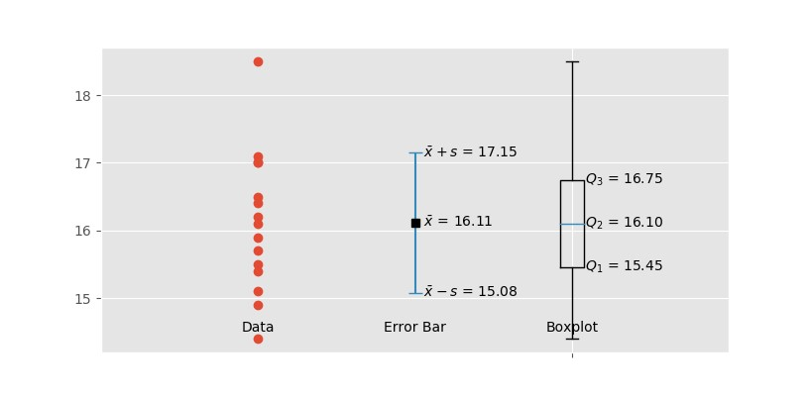

1. We consider the linear algebra problem 𝐴𝑥 = 𝑏 where the system matrix and the right-hand-side vector are:

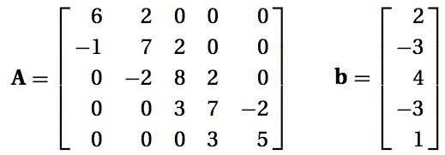

Use python, to compute the following. Copy your solutions to the answer sheet.

* 1. Transpose of matrix A and vector b
  2. The Euclidean norm of the vector 𝑥.

*# --------------------------------  
# 2*A = np.array([  
 [6, 2, 0, 0, 0],  
 [-1, 7, 2, 0, 0],  
 [0, -2, 8, 2, 0],  
 [0, 0, 3, 7, -2],  
 [0, 0, 0, 3, 5]  
])  
  
b = np.array([  
 [2],  
 [-3],  
 [4],  
 [-3],  
 [1]  
])  
  
*#2 a)*transpose_A = np.transpose(A)  
transpose_b = np.transpose(b)  
print(**"Transpose A"**, transpose_A)  
print(**"Transpose b"**, transpose_b)  
  
*#2 b)*x = np.linalg.solve(A, b)  
norm = np.linalg.norm(x)  
print(**"Euclidean norm of vector x "**, norm)

1. If |x| < 1, it is known that:

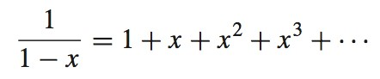

* 1. Write a python function that compute 1/(1-x) for x = 0.1. Your function should have the following interface that allows the user to adjust the number of the terms of the series 𝑛.

def taylor_1(x, n):

# Your codes

* 1. Use your function to compute 1/(1-x) with x = 0.1 by using the first 5 and 10 terms of the series.
  2. Compute the relative errors of the results in (b).

*#---------------------------  
#3 a)***def** taylor_1(x,n):  
 a = 0  
 **for** i **in** range(1, n + 1):  
 a = a + x**i  
 **return** 1 + a  
  
*#3 b)*tay_5 = taylor_1(0.1 , 5)  
tay_10 = taylor_1(0.1, 10)  
  
print(**"5 terms"**, tay_5)  
print(**"10 terms"**, tay_10)  
  
*#3 c)*original = 1/(1-0.1)  
error_5 = original - tay_5  
error_10 = original - tay_10  
print(**"Original"**, original)  
print(**"Error 5 "**, error_5)  
print(**"Error 10"**, error_10)

1. Compute the exact solution and the numerical solution for the problem:

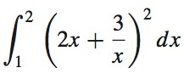

As for the numerical solutionusing Gauss quadrature with two quadrature points of 𝜉’ = −0.577350 and 𝜉. = +0.577350, and the two points have the same weight of 𝐴0 = 1.0. Compute the relative error of the numerical solution compared to the exact integration result.